**Designing a travel planning app**

**- a design coursework**

By Anh hoang

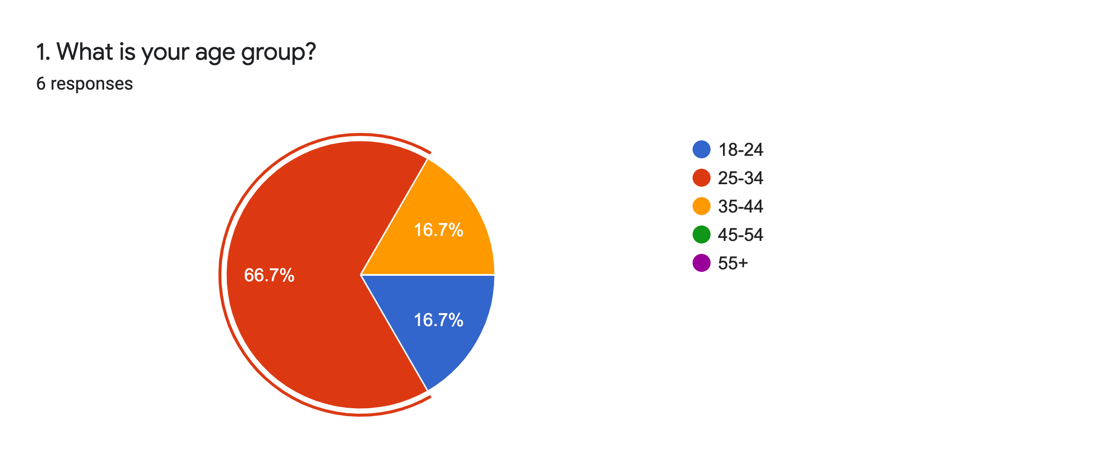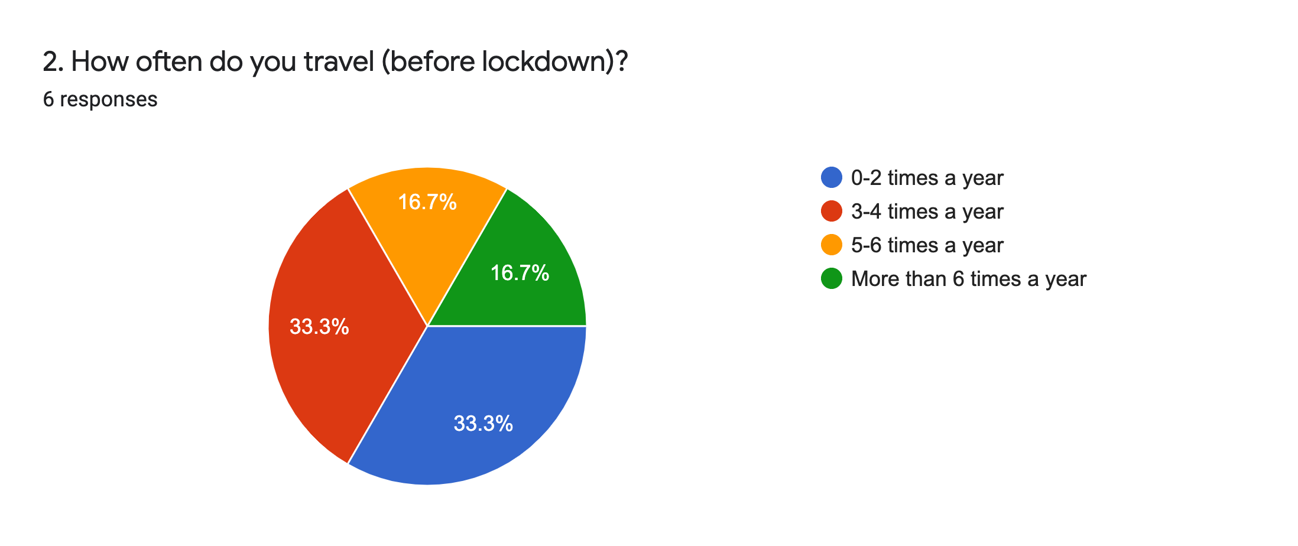**Quantitative date collected from survey**

Participants varied in age which predicted the trends in planning holidays/ trips.

The targeted age group (25-34) on average, travel 3-4 times a year

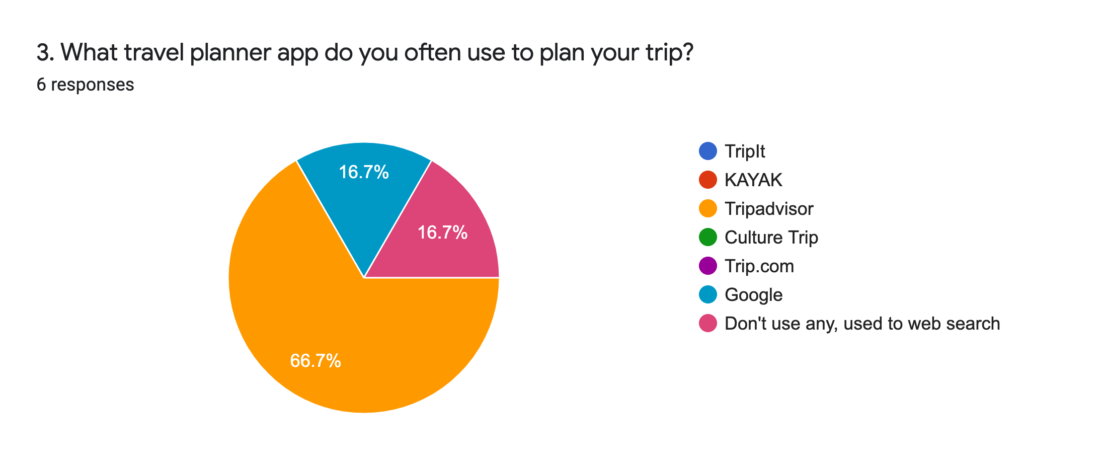

Some specialised trip planning apps are unfamiliar with participants, except TripAdvisor.

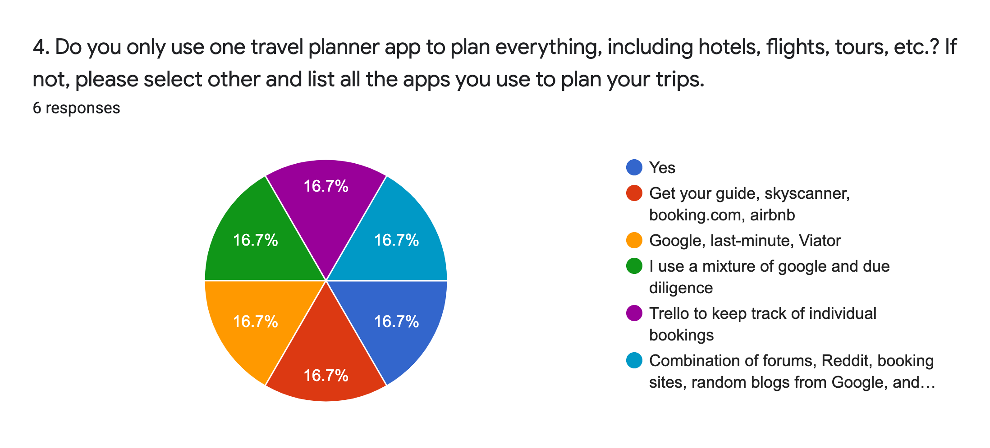

Participants tend to search for their trips on different websites and forums than planning their trips on a specialised trip planning app.

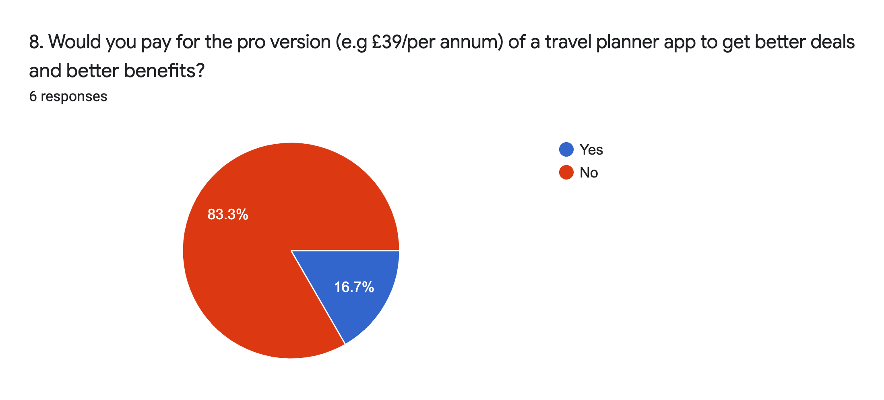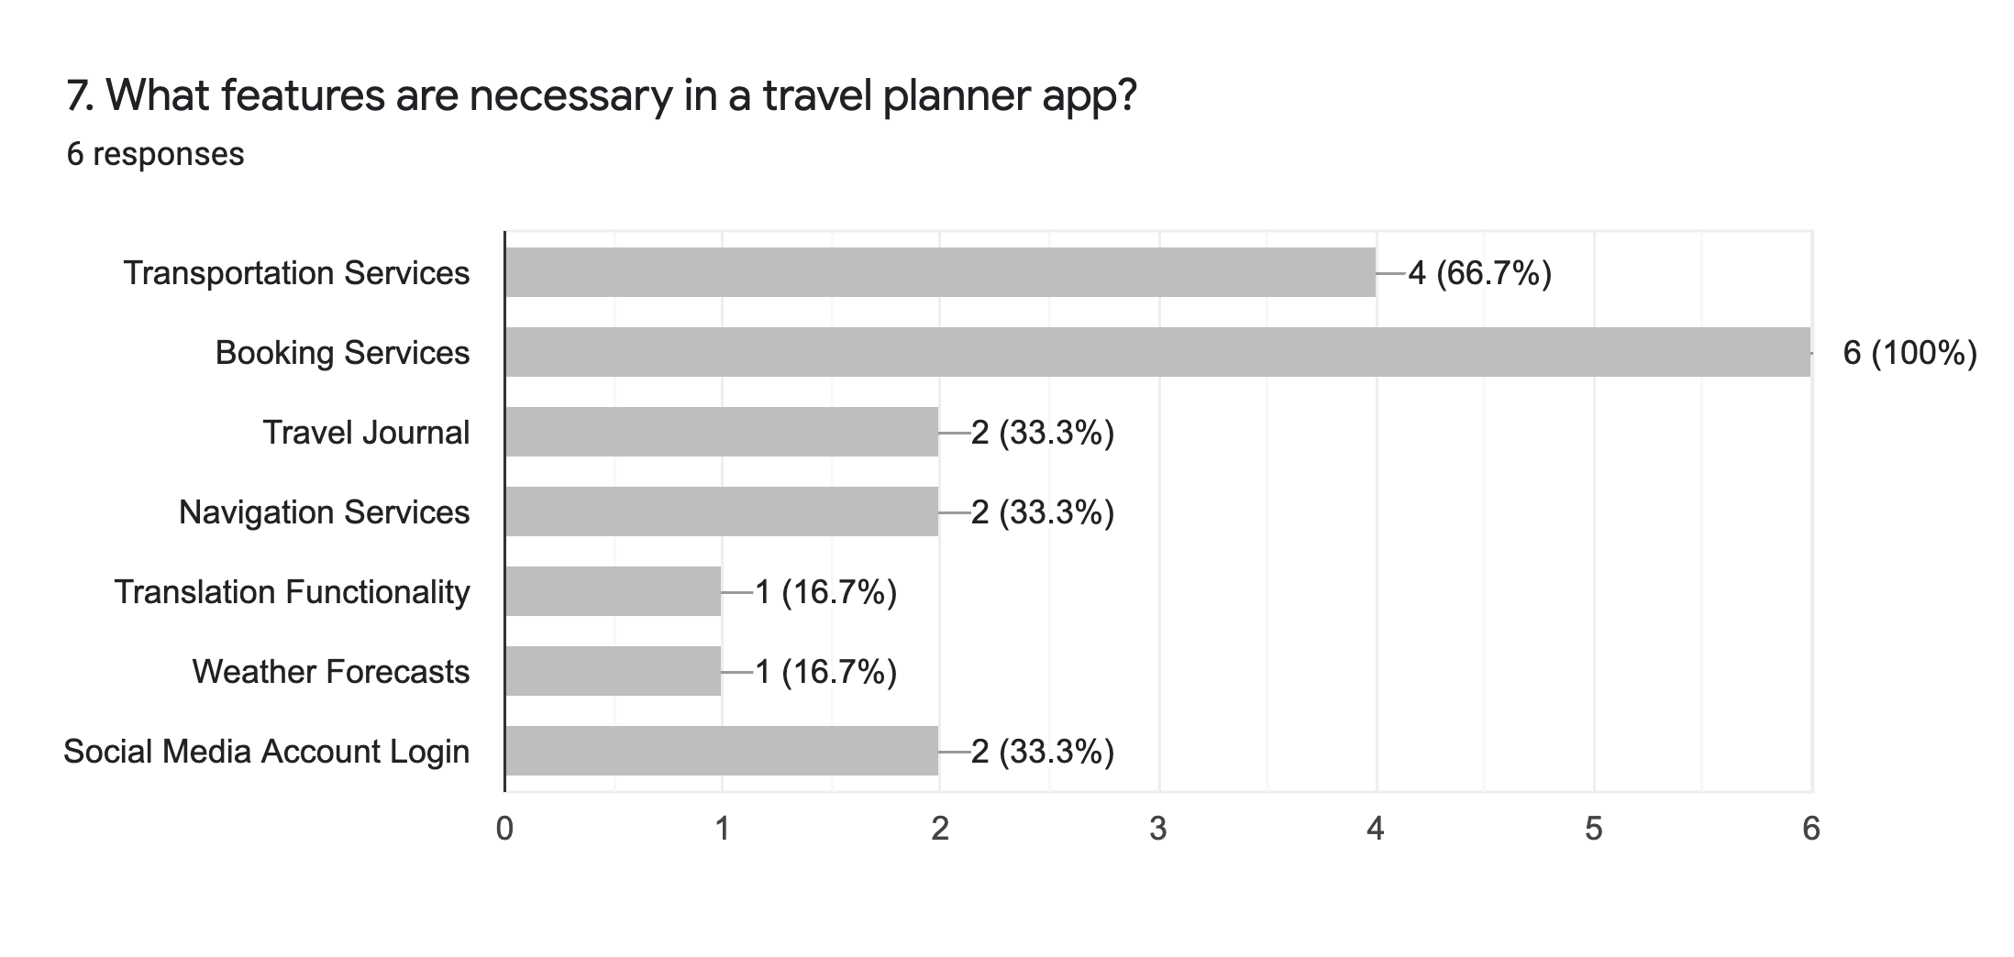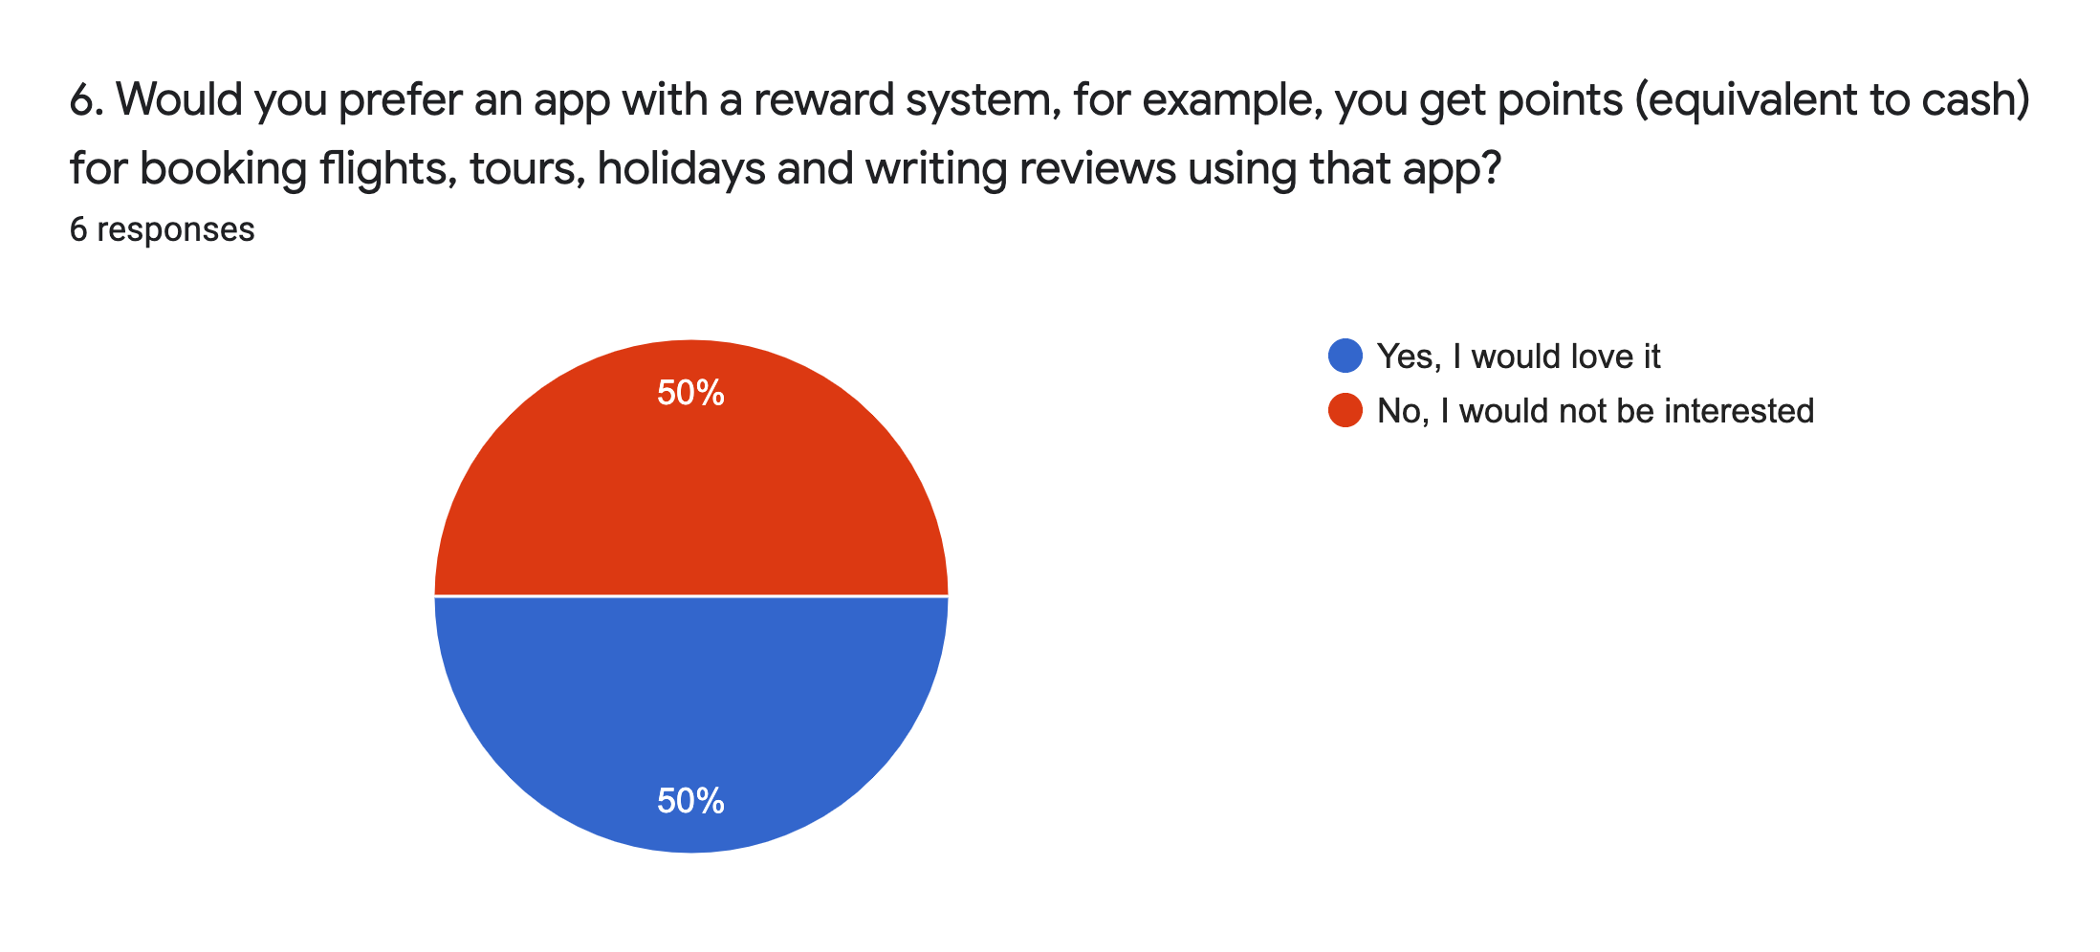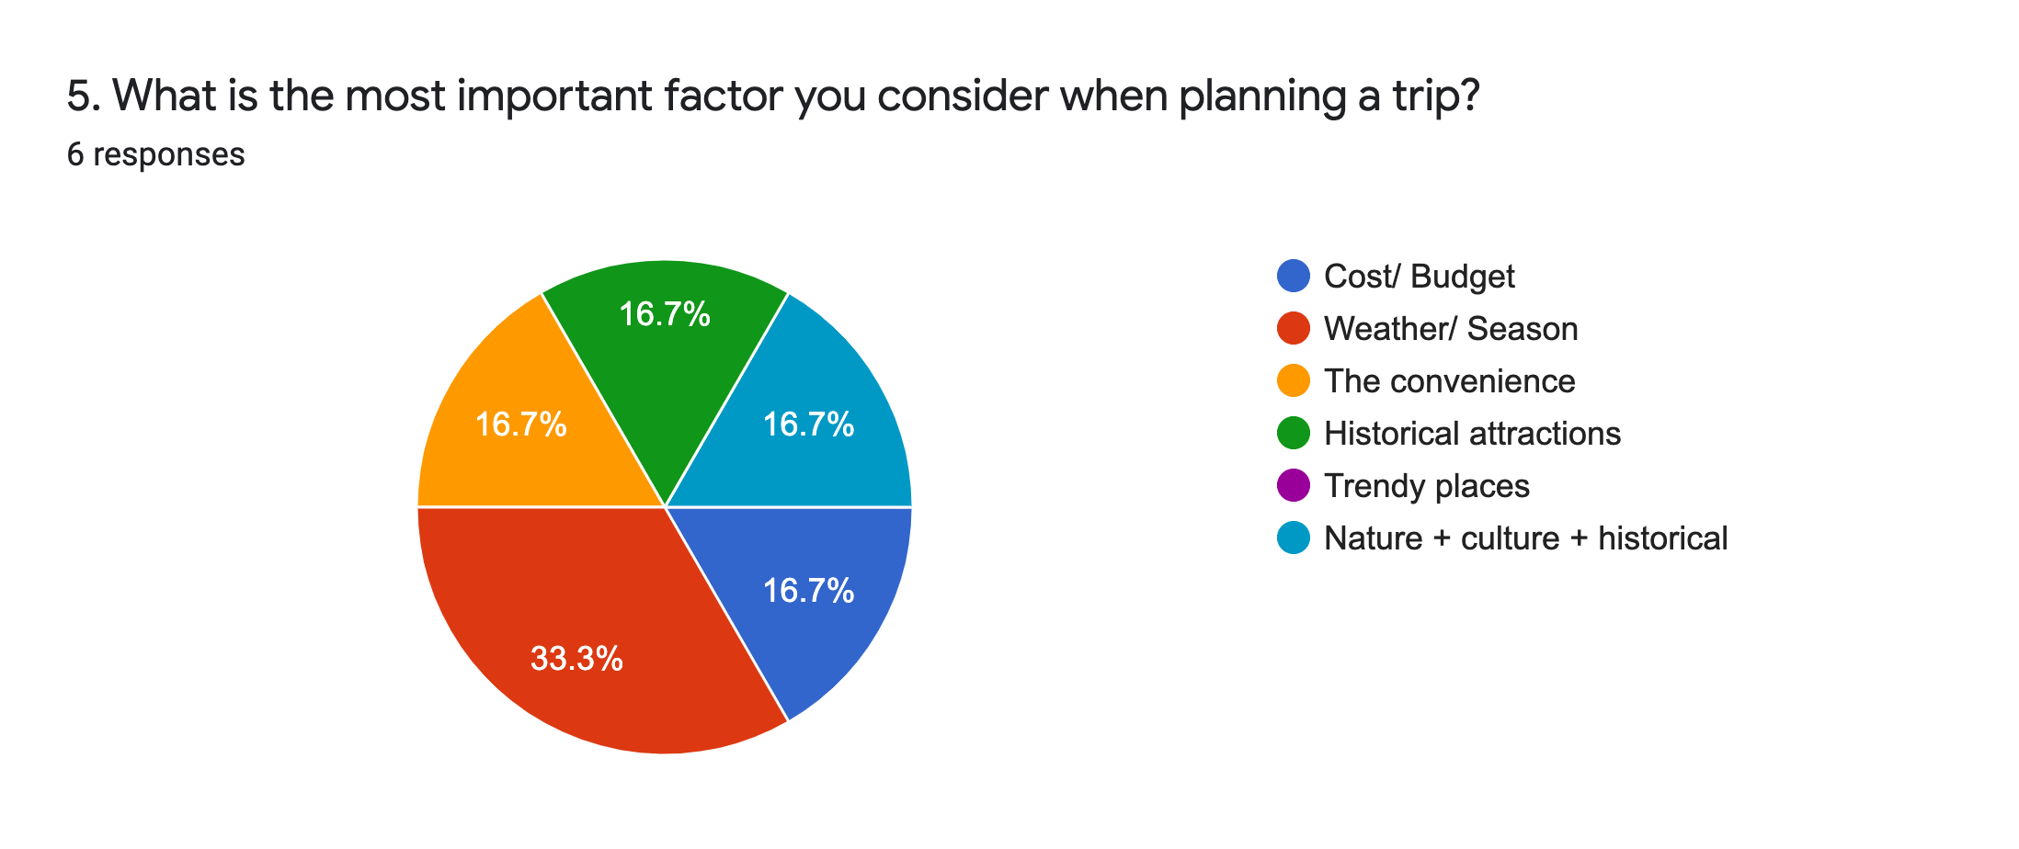

A pro version is not preferred, participants prefer a free app with

useful features

Booking Services and Transportation Services are required features for a travel planner app

Weather/ Season are important factors for participants when planning their trips. A reward system is not preferred.

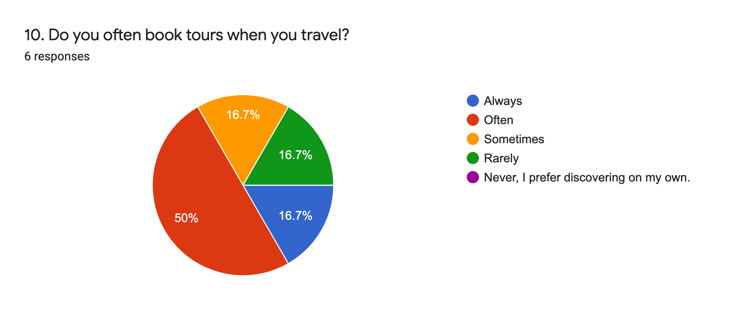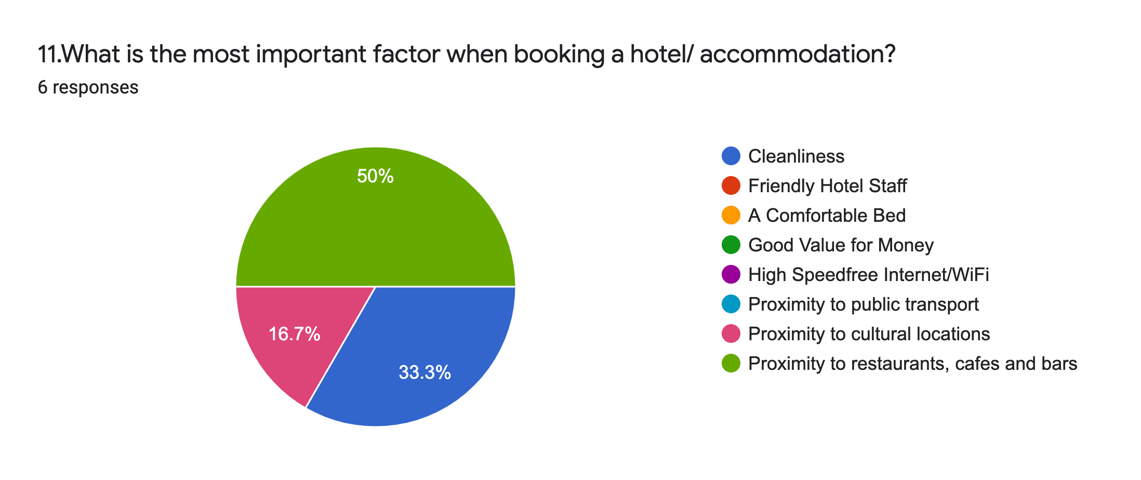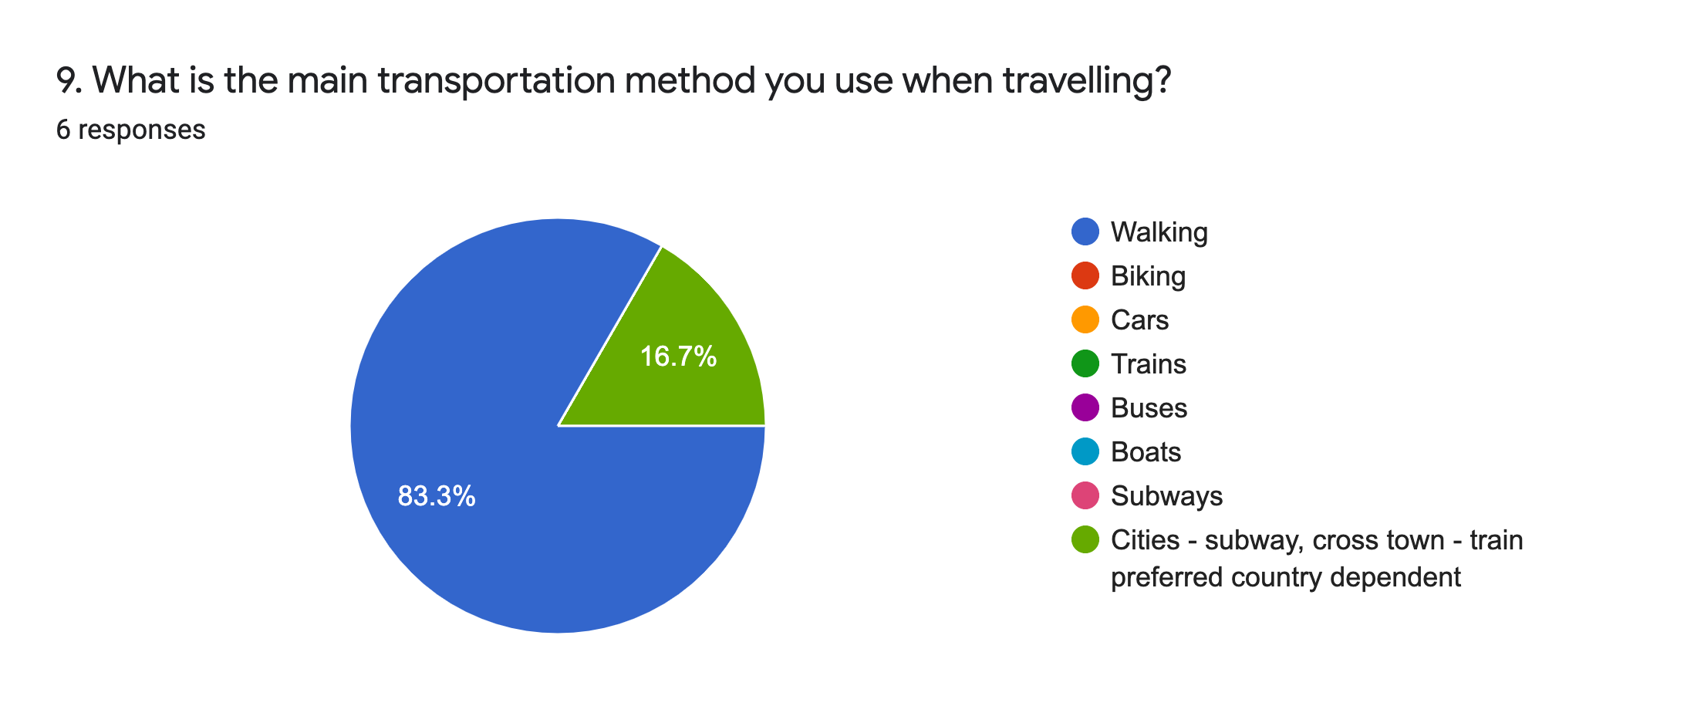

50% often book tours, showing the importance of tour guides for travellers. This suggests a trend and demand in tours, to help travellers save time when planning their trips.

The majority of participants picked walking as the main transportation method. This means that car hire feature is not needed in a travel planning app.

2. Define

|  |  |
| --- | --- |
| **Feature** | **Description** |

**Must Have**

**Nice To Have**

**Can Come Later**

* Users could make payments for their bookings directly from the app
* Calculator that allow users to convert any currency to country they are visiting
* An online, available 24/7 bot to provide general help with features of the app
* More languages available for easily accessible
* A program allowing users to plan their trips step by step, from selecting multiples destinations to flights to hotels, etc.
* Make changes, add destinations to booking details
* Create, edit and update personal information
* Users personal information, such as name, email, address, phone number
* Reviews from other users including information about their previous trips, tips and travel advice
* Allow users to keep a journal to cover the entirety of their trip, e.g. pictures, diary
* Guide for users to protect themselves when travel during the pandemic
* Information about a destination, including attractions, accommodation, activities, etc.
* Users would be able to locate train stations, bus stations, and forms of public transportations with ease
* Users can seek to them asking for help if needed
* Provide locations of local hospitals and police stations

* Integrate users social media accounts directly into the app to speed up registration time
* An option for users with additional needs
* Grant users the ability to plan ahead without having to utilise separate apps
* Travellers can feel free to move about without the fear of a language barrier from signs, street maps, or locals

**Payments**

**Currency Converter**

**Chatbot**

**Different Languages**

**Transportation Services**

**Virtual Assistant**

**Local Emergency Services**

**Social Media Account**

**Car Hire**

**Weather Forecasts**

**Translation Functionality**

**Trip Planning**

**Manage Bookings**

**Login/ Signup**

**Account Profile**

**Reviews**

**Travel Journal**

**Safety Guides**

**Travel Guides**